Documentation for saving Toponyms
Content
How saving toponyms algorithm works now 1
1. Downloading and Extracting Data: 1
2. Processing CSV Files: 1
3. Fetching Coordinates: 2
4. Database Integration: 2
Description of the algorithm 2
What needs to be done 3
How saving toponyms should work 3
1. Downloading and Extracting Data: 3
2. Processing Toponyms Data: 3
3. Fetching Coordinates: 3
4. Error Handling and Validation: 3
Expected results 4

How saving toponyms algorithm works now
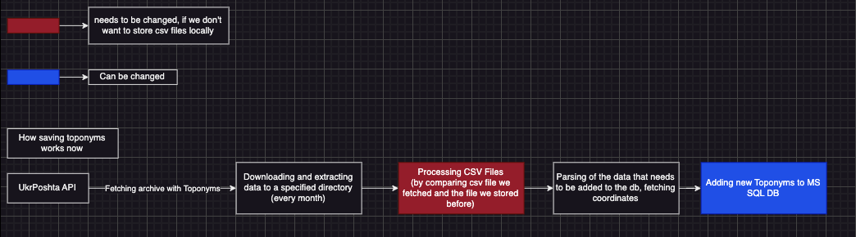

Downloading and Extracting Data:
- Downloads a ZIP file from a predefined URL.
- Extracts the ZIP archive to a specified directory.

Processing CSV Files:
- Reads and processes address data from CSV files.
- Deduplicates rows and updates the local dataset with any new or modified data.
- Supports encoding adjustments for proper file parsing.

Fetching Coordinates:
- Uses the OSM Nominatim API to fetch geographical coordinates (latitude and longitude) for provided addresses.
- Implements retry and circuit breaker policies using Polly to handle API failures.

Database Integration:
- Saves processed address and coordinate data as Toponym entities in the database.
- Ensures data integrity by removing outdated records before inserting new ones.
- Error Handling and Validation:
- Validates URLs, paths, and input data.
- Logs errors to the console with helpful messages.

Description of the algorithm
We download a ZIP file from a predefined URL and extract it to a specified directory. After extracting we have a houses.csv file in DAL. Then, in order not to replace all existing toponyms that we stored before, we compare houses.csv and data.csv, after comparing we delete the unnecessary toponyms from data.csv and add parsed new toponyms from houses.csv to data.csv. After updating our data.csv file we optionally delete houses.csv file, truncate our toponyms table in our MS SQL db, and add all the data from data.csv to toponyms table.

For more information on how it works you can read Map documentation.

What needs to be done
The main goal of this task is not to store .csv files locally. You need to replace .csv file/files(optionally) with NoSQL Database for Toponyms Storage. You need to change the way of processing our toponyms data and saving it to the db.

How saving toponyms should work
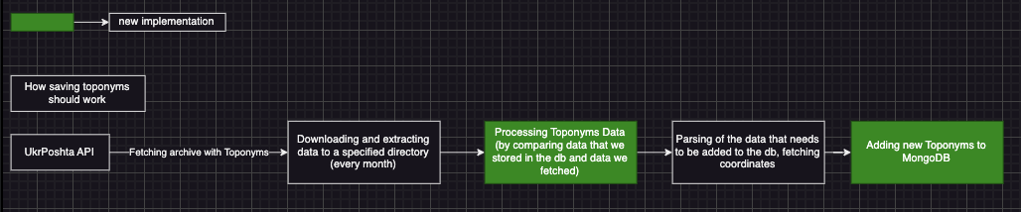

Downloading and Extracting Data:
- Downloads a ZIP file from a predefined URL.
- Extracts the ZIP archive to a specified directory.

Processing Toponyms Data:
- Reads and processes address data from CSV houses.csv file.
- Converts all the data from houses.csv file into Toponyms list (parsing this data on this stage may be optional)
- Then you need to compare Toponyms list with existing toponyms in our db, delete the unnecessary toponyms from the db, parse and add new toponyms into our MongoDb.

Fetching Coordinates:
- Uses the OSM Nominatim API to fetch geographical coordinates (latitude and longitude) for provided addresses.
- Implements retry and circuit breaker policies using Polly to handle API failures.

Error Handling and Validation:
- Validates URLs, paths, and input data.
- Logs errors to the console with helpful messages.

Expected results
There are no houses.csv, data.csv files stored locally. All the toponyms are stored in MongoDb. The Toponyms table in SQL db no longer exists. The logic of updating our toponyms data in Mongodb is working.

